Aaron Lajom

**Executable**

Found in the executable folder. Named: Game.exe

**Controls**

Camera – From the Menu select Navigation -> Camera Control

* Hold Left Mouse Button while Moving Mouse: Rotate camera around Plane
* Middle Mouse button + move mouse: Zoom in and out of plane
* A or S: Zoom in and out of plane

Car First Person – From the Menu select Camera View -> First Person

* Left or Right: Rotate 90 degrees counter clockwise and clockwise respectively
* Up or Down: Move forward or back respectively according to selected player speed
* A or S: Lower or raise camera (traverse Y axis)
* Spacebar: shoot a projectile. Takes a couple of seconds to reload.

Car Third Person

* Left or Right: Move along X axis
* Up or Down: Move along Z axis

Light – From the Menu select Navigation -> Light Navigation

* Hold Left Mouse Button while Moving Mouse: Rotate light around Plane

The project file can be found in GraphicsAssignment2\ directory (named “GraphicsAssignment2”)

**Screenshots**

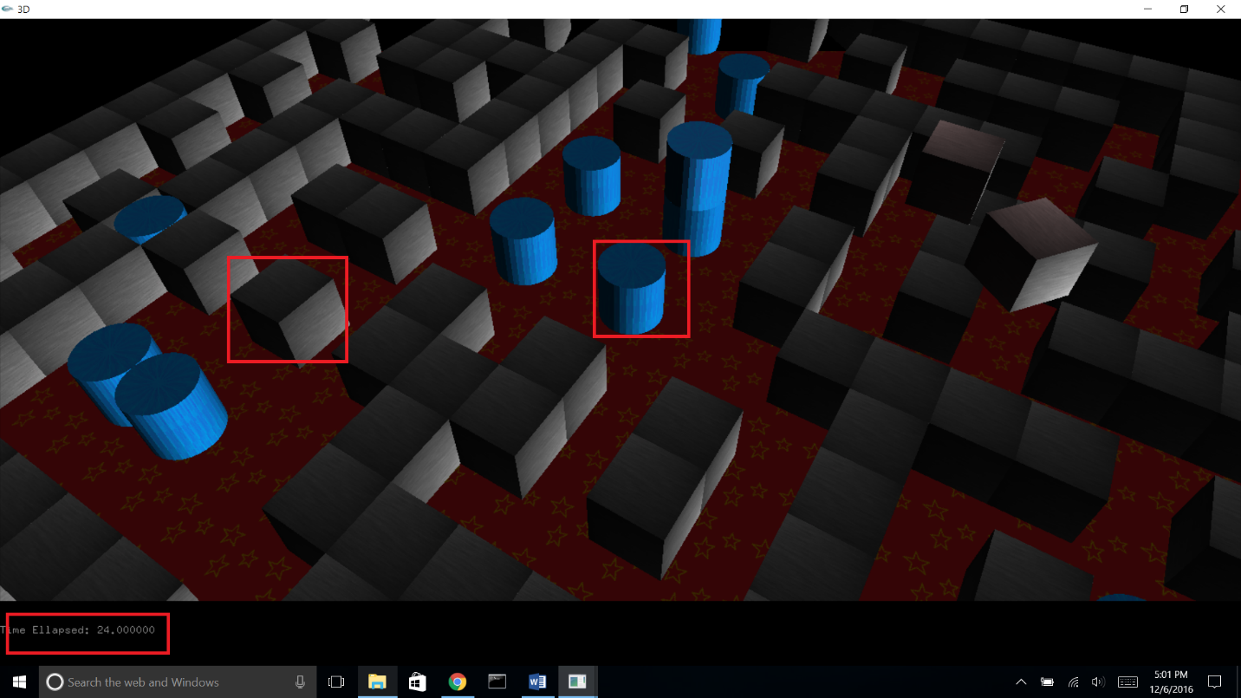

Evidence of Timer, 2 viewports, textures, lighting

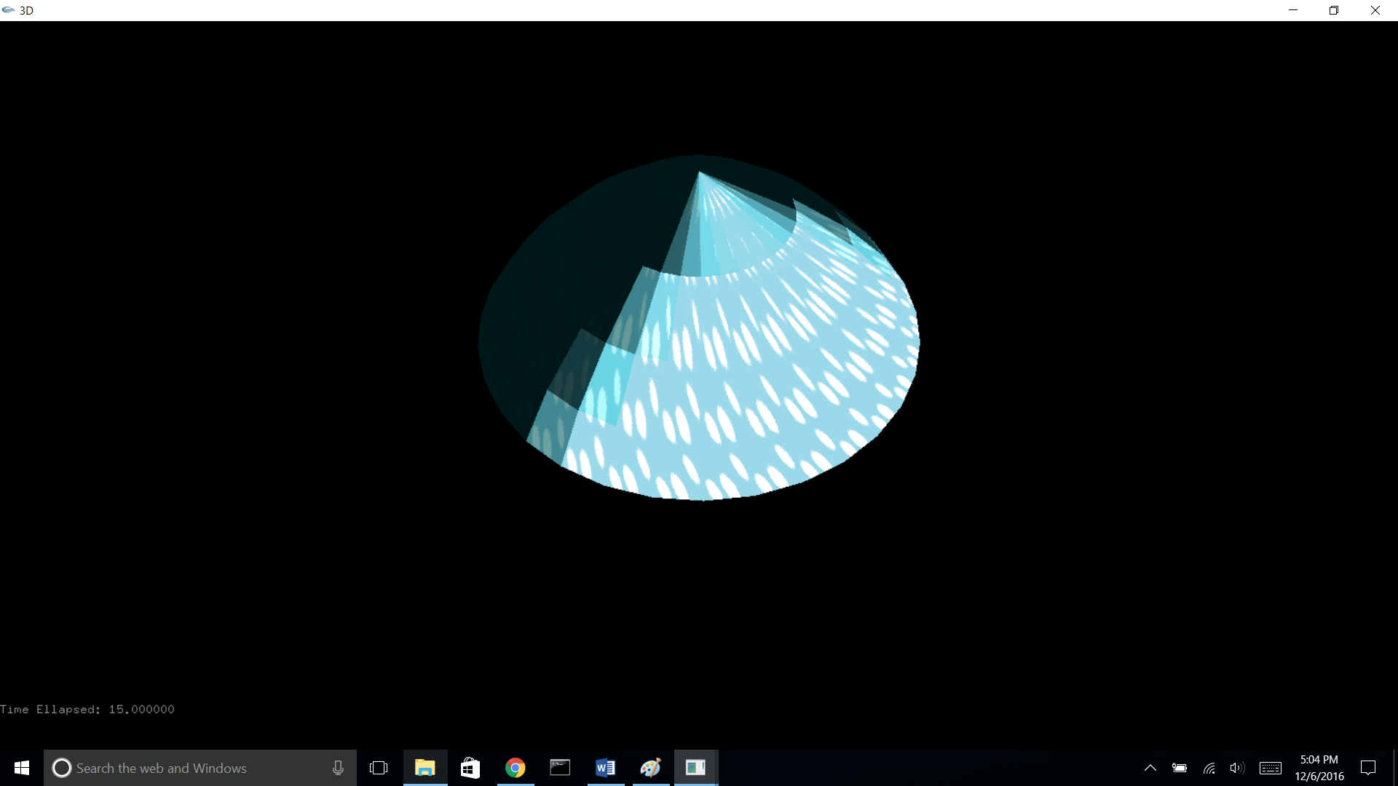

The dome

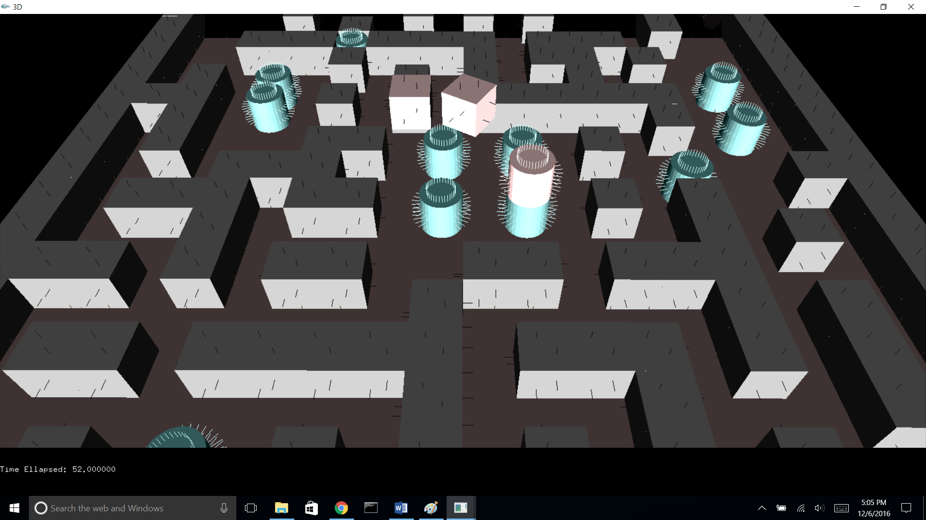

Evidence of perFace Normal visualization, toggle textures, and materials

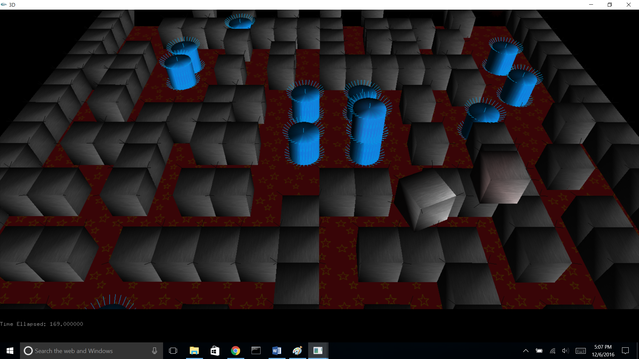

Per Vertex lighting and visualization

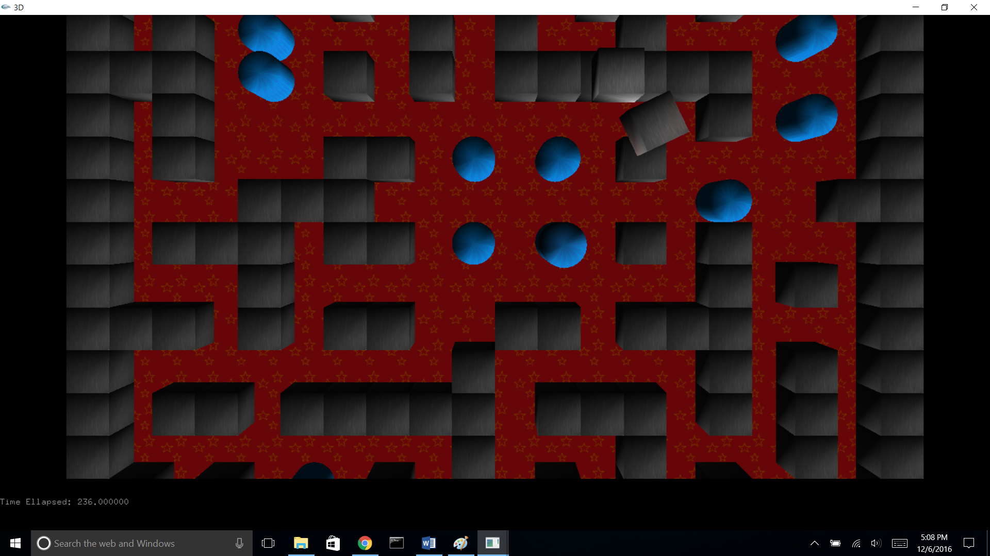

Top Down View

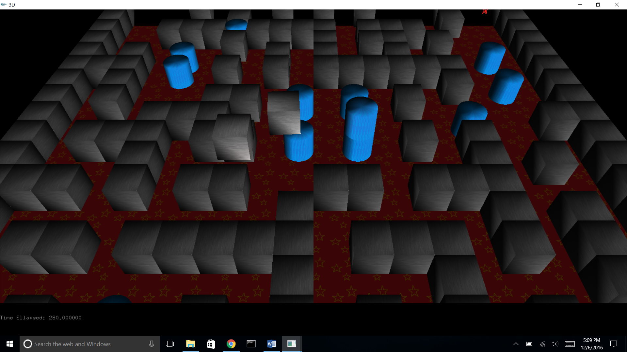

45-degree view

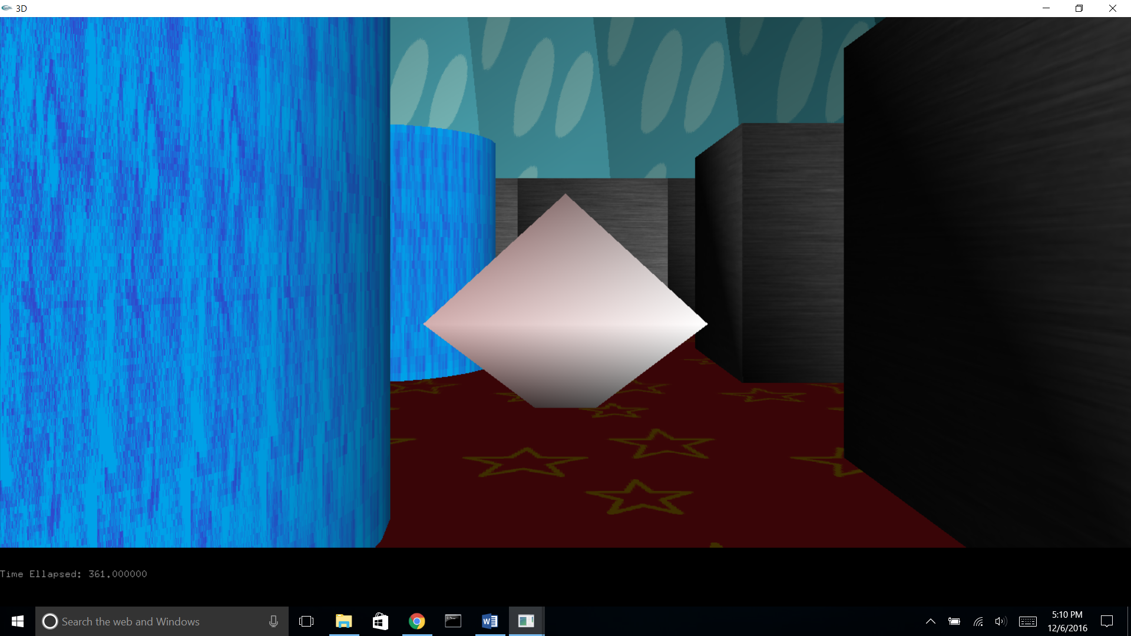

First Person view + Projectile, Inside visualization of dome

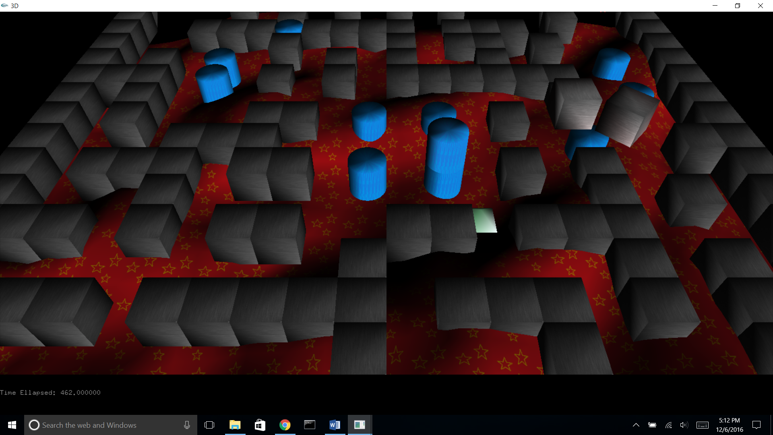

Multiscale noise

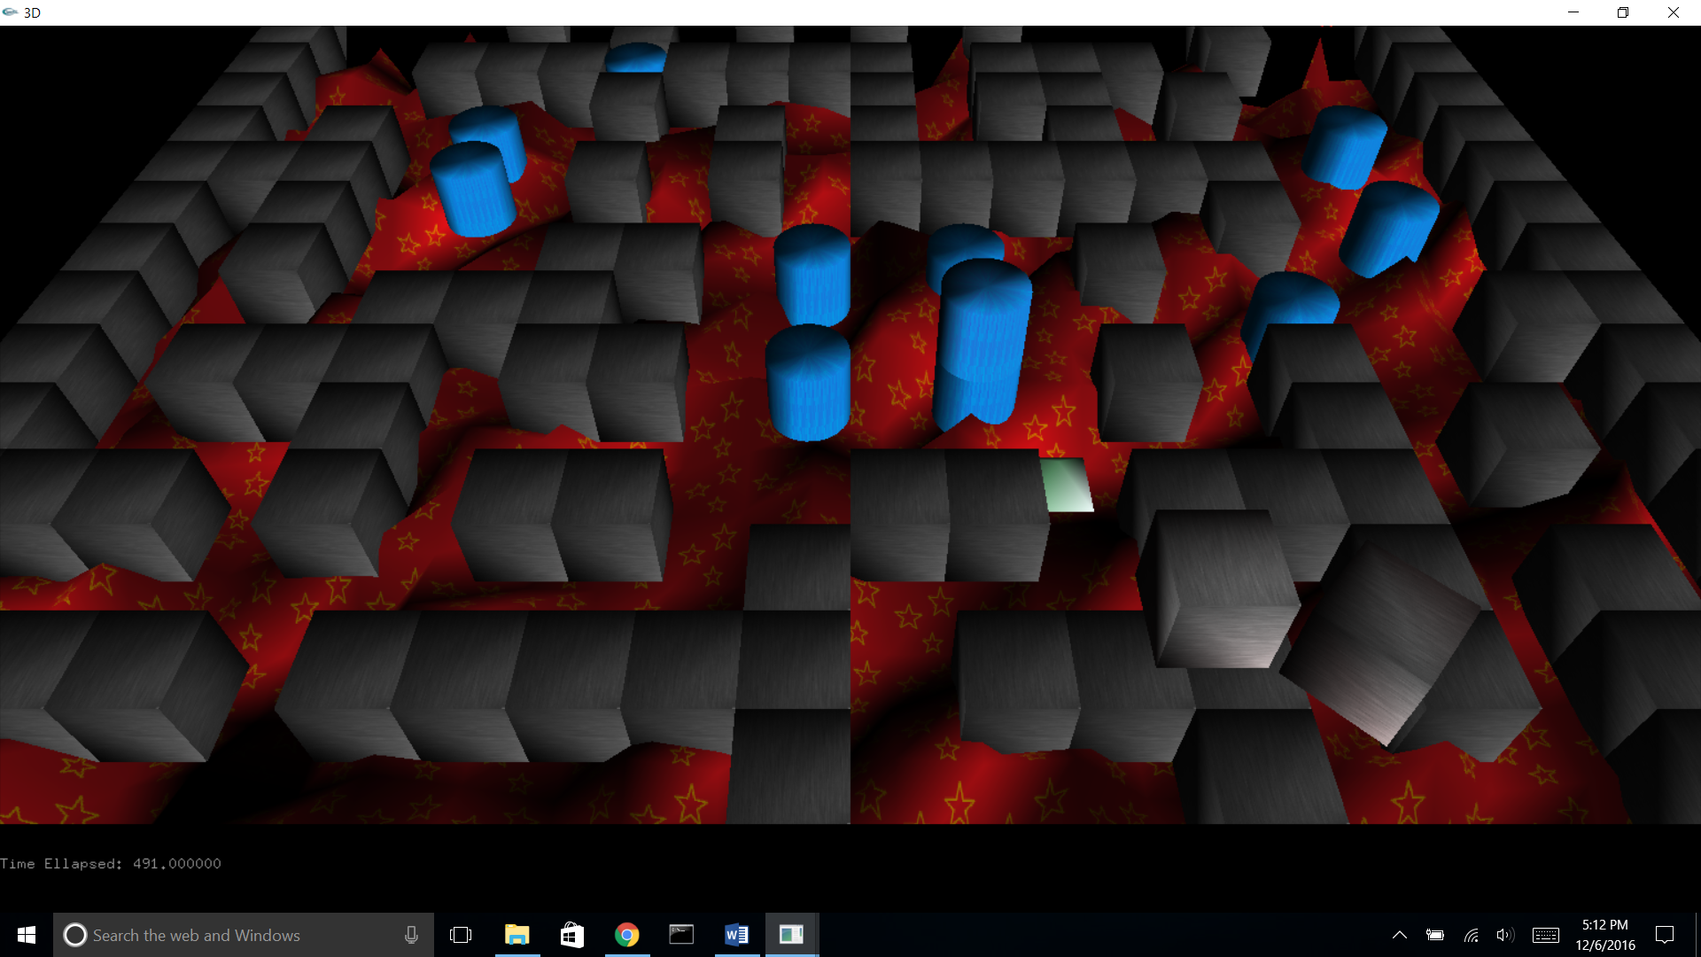

Marble noise

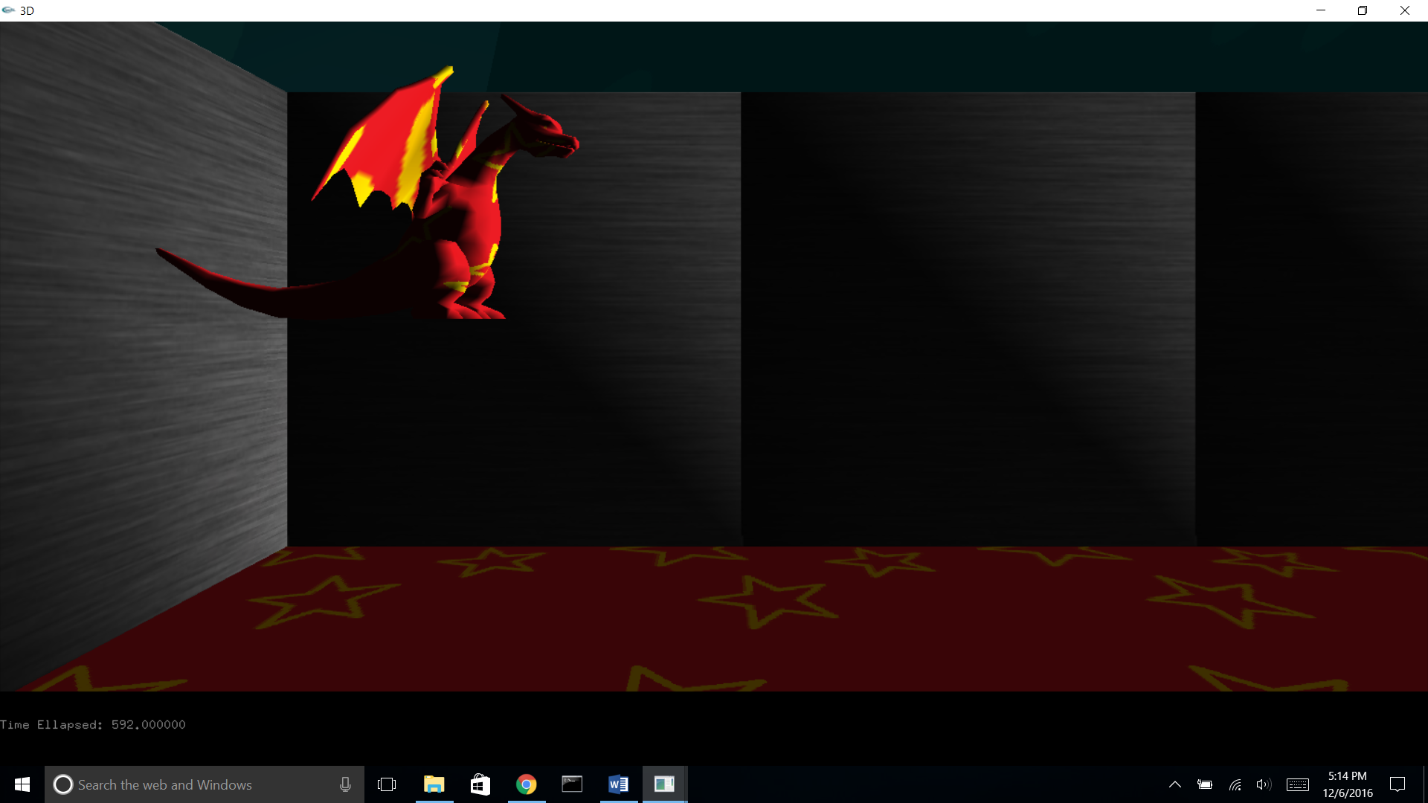

Use of object loader